
WALTON & WEYBRIDGE REGATTA
(Under BR Rules of Racing and in accordance with BR’s Row Safe Code)
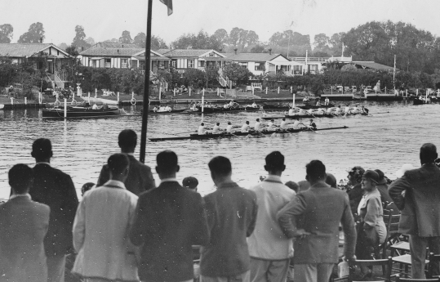
Formerly
Walton Amateur Regatta
Established in1862
150th Anniversary Regatta - Saturday 26th May 2012
1000m Downstream on the River Thames between Walton Marina and Miskins Wharf
Events:

ALL EVENTS (except Invitation Eights) will take place from stakeboats over a two-lane buoyed course and will be decided by knock-out competitions.
INVITATION EIGHTS: To celebrate the 150th anniversary there will be non-status Invitation Eights raced over 500m for four Open and four Women’s crews each for a £250 prize.
PRIZES: Special 150th Anniversary medals will be presented to winners of all events.
MASTERS EVENTS: Masters’ age classifications offered will depend on entries received.
MASTERS NOVICE EVENTS: Competitors must be both Masters AND Novices. There is no handicapping by age.
J13 4x+ will allowed with any combination of boys and girls.

ENTRIES: May only be made on-line through the British Rowing website. No postal or e-mailed entries will be accepted. Entries will close at 1200 on Sunday 20th May 2012; the draw will take place at Weybridge RC thereafter. Payment must be made by cheque to the Entries Secretary in favour of 'Walton & Weybridge Regatta', and posted to: ENTRIES SECRETARY, WALTON & WEYBRIDGE REGATTA, 32 Holme Chase, Weybridge Surrey KT13 0BZ.

ENTRY FEES: Eights £88, Fours (4+, 4-, 4x+, 4x-) £44, Doubles £22, Singles £11.
The Regatta Draw and full instructions will be available on the Regatta website: wandwregatta.org.uk
Please ensure that the contact information that appears on a Club's entries is correct and complete.

The Regatta offers a wide range of events, but is limited as to the number of races it can accommodate. The Committee therefore reserves the right to refuse entries which are incomplete or not accompanied by full payment, and to cancel any event with insufficient entries. In the case of what it judges to be insufficient entries for a viable event, the Committee will transfer the entry to the next higher class without reference, unless it is made clear on the entry that this is not acceptable. If a crew wishes not to be accommodated by this method, preferences must be made clear in the free-text part of the BROE entry.

